Assignment week 13

By

Ujjwal Bhasin 200389272

Relational Databases

Maziar Shazari

**Part 1**

STEP 0

CREATING TABLES IN WEEK 12 – BOYS, GIRLS AND TOYS

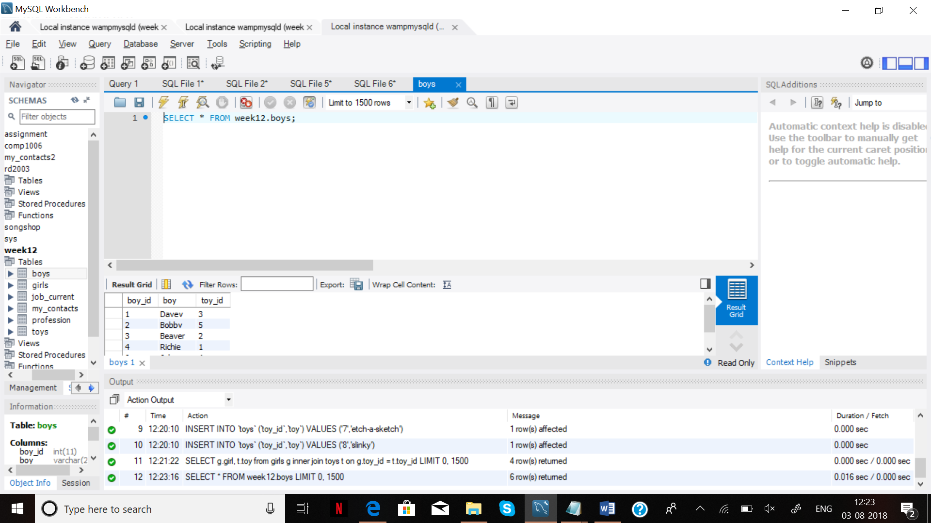

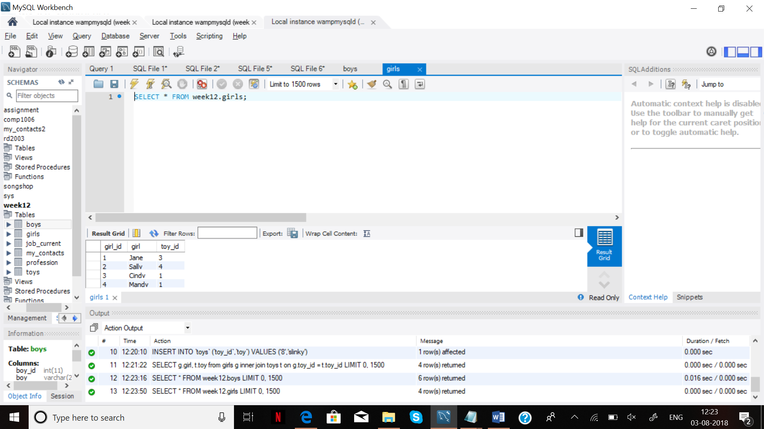

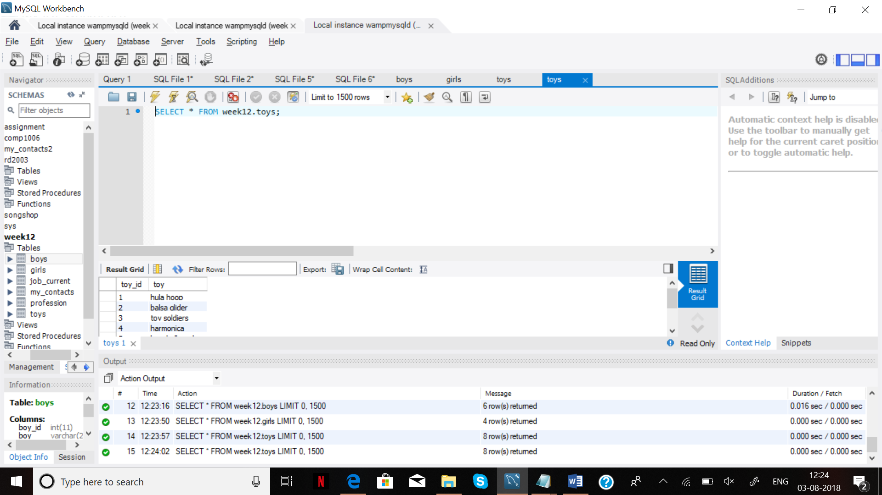

STEP 1-

SELECT g.girl, t.toy

from girls g

inner join toys t

on g.toy_id = t.toy_id;

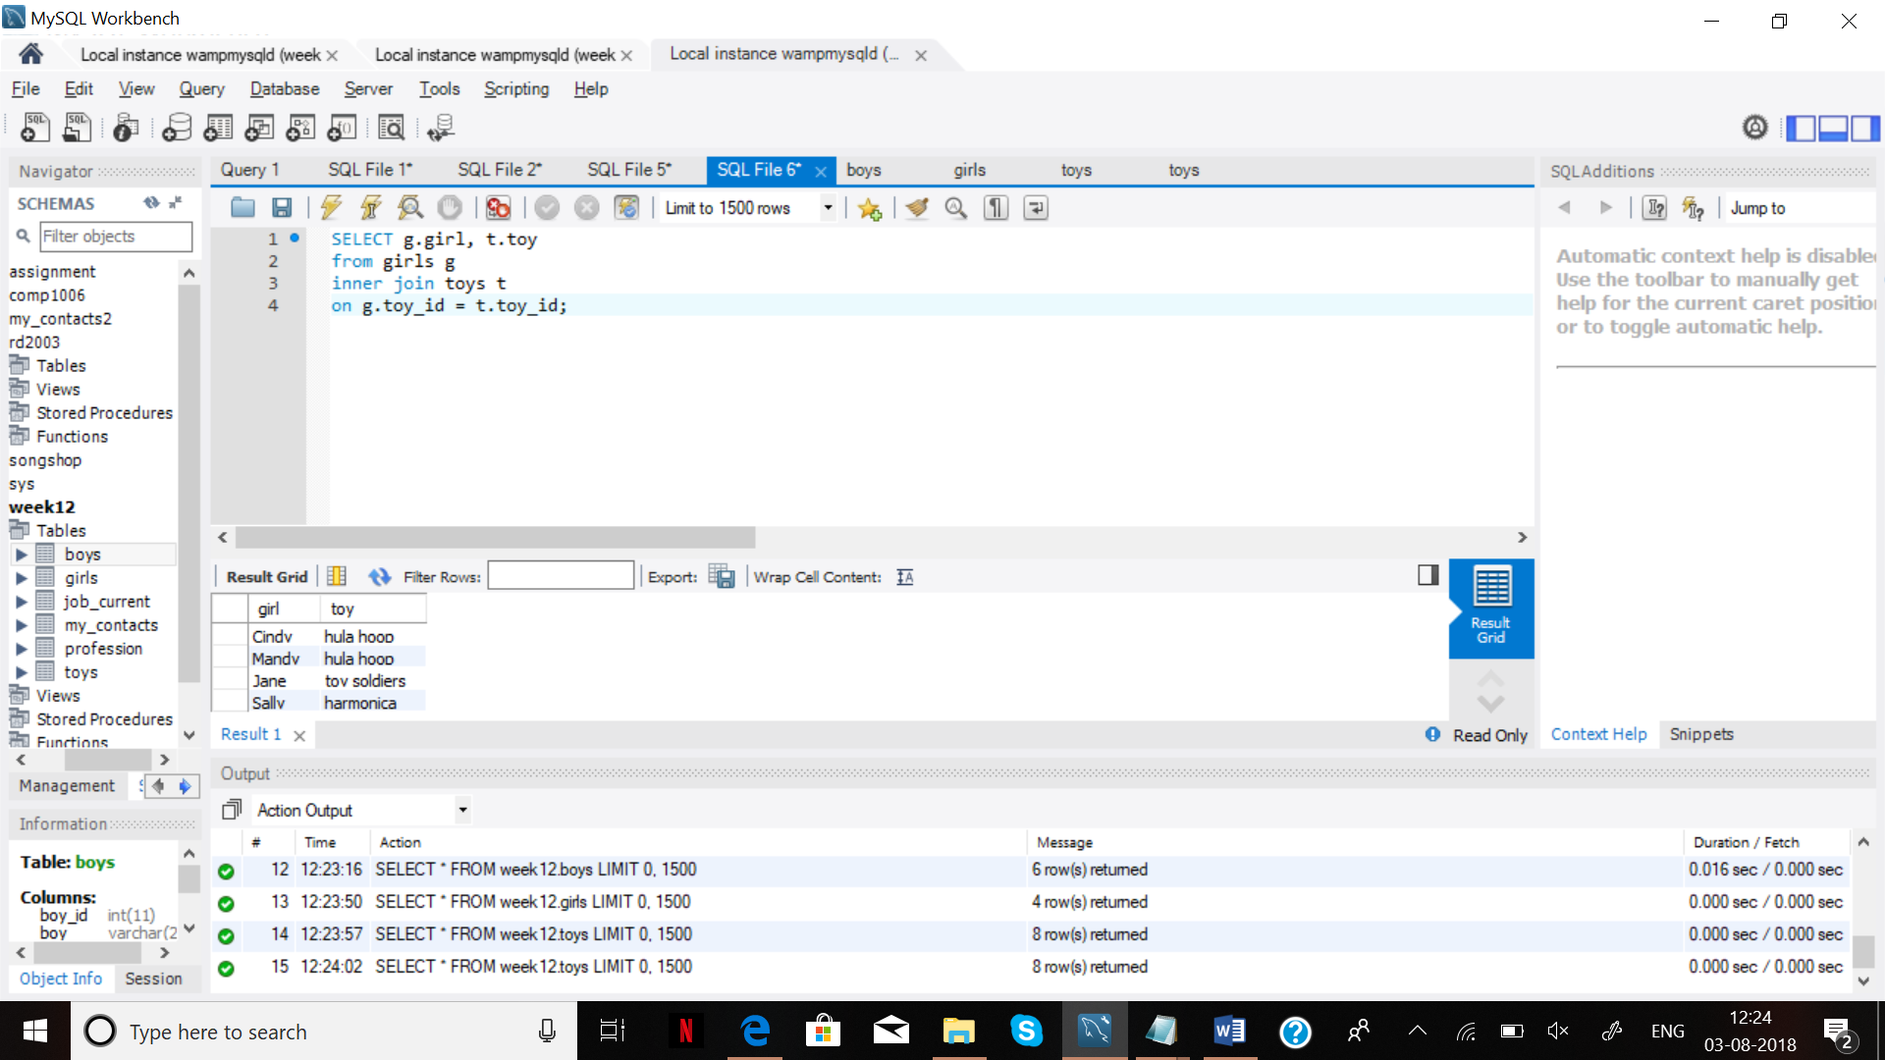

STEP 2-

SELECT g.girl, t.toy

from girls g

LEFT OUTER JOIN toys t

ON g.toy_id = t.toy_id;

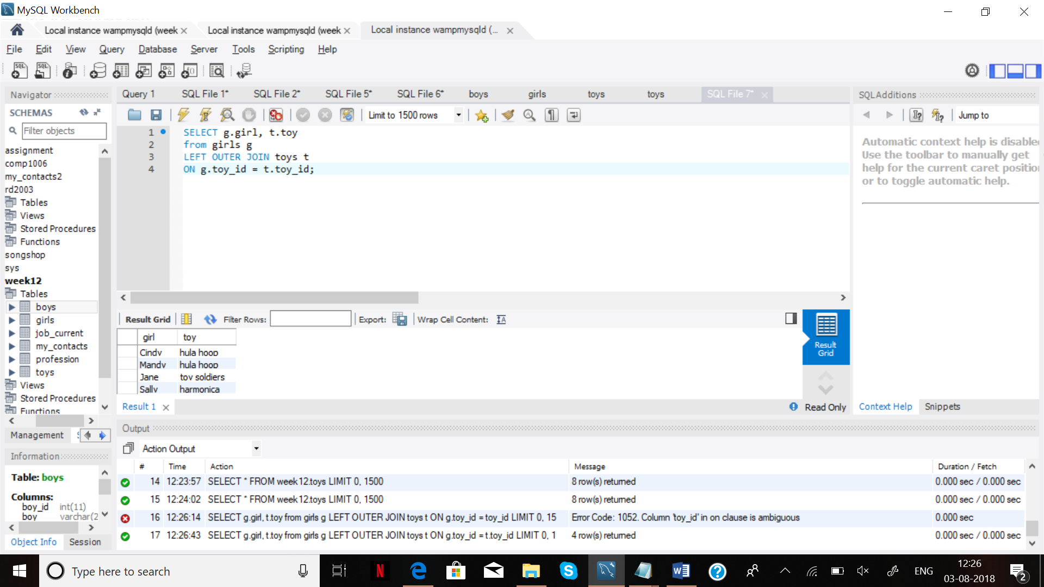

STEP 3-

SELECT g.girl, t.toy

from toys t

LEFT OUTER JOIN girls g

ON g.toy_id = t.toy_id;

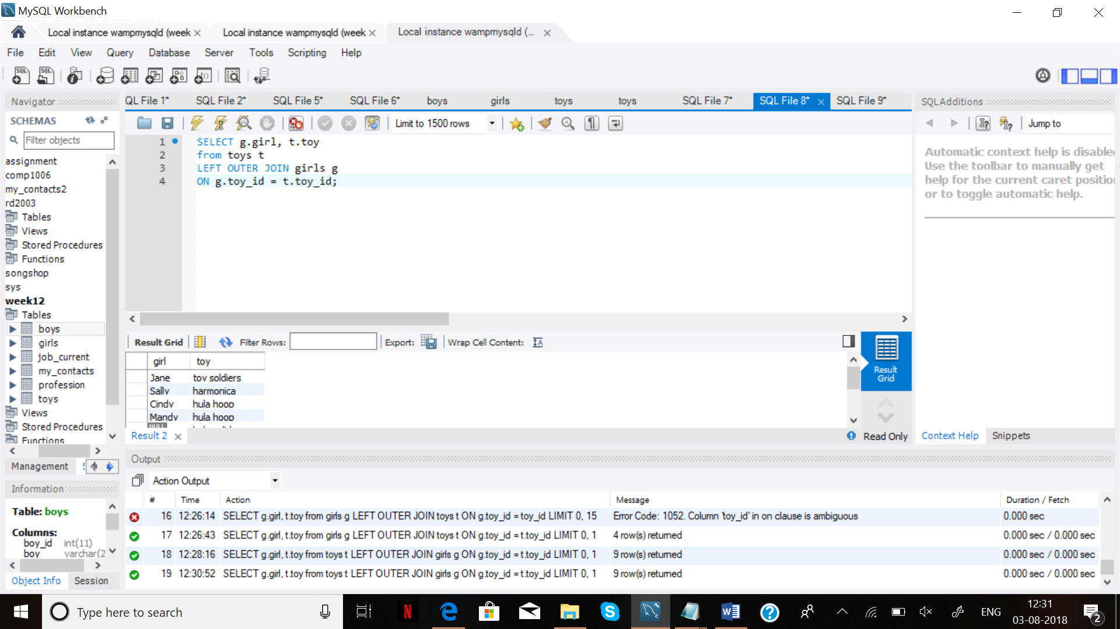

STEP 4-

SELECT g.girl, t.toy

from toys t

RIGHT OUTER JOIN girls g

ON g.toy_id = t.toy_id;

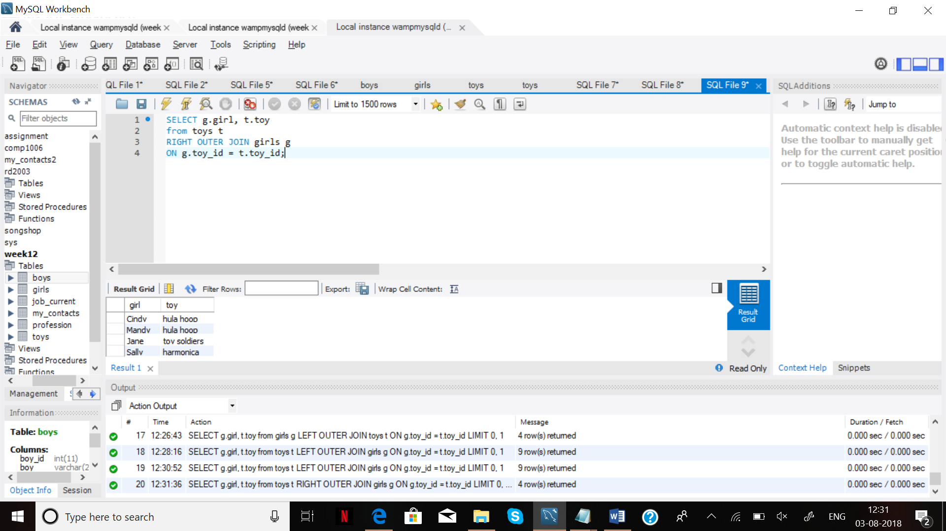

STEP 5 –

SELECT toy

FROM toys

UNION SELECT boy

FROM boys;

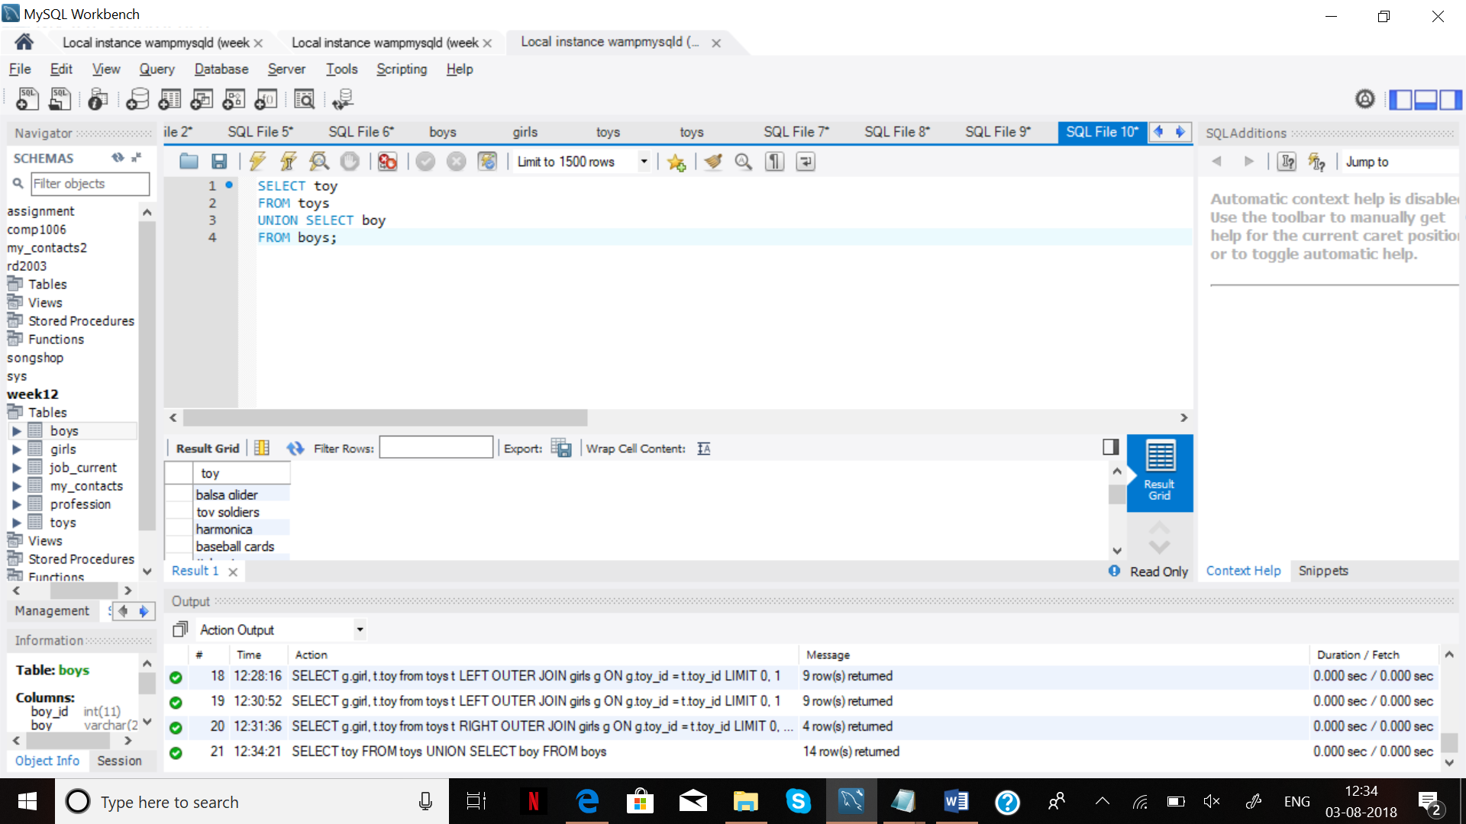

SELECT toy AS results

FROM toys

UNION SELECT boy_id

FROM boys;

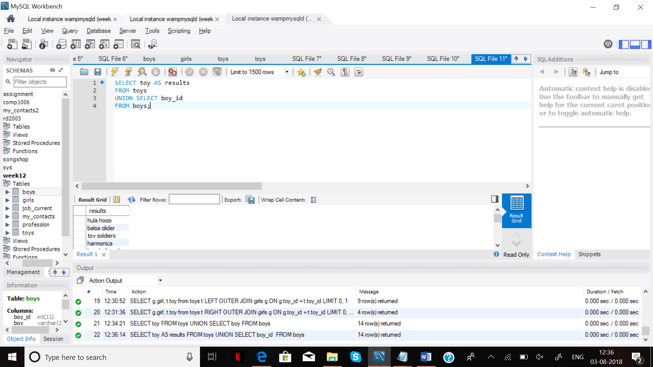

**PART 2**

**STEP 1**

1. CREATE DATABASE week13;

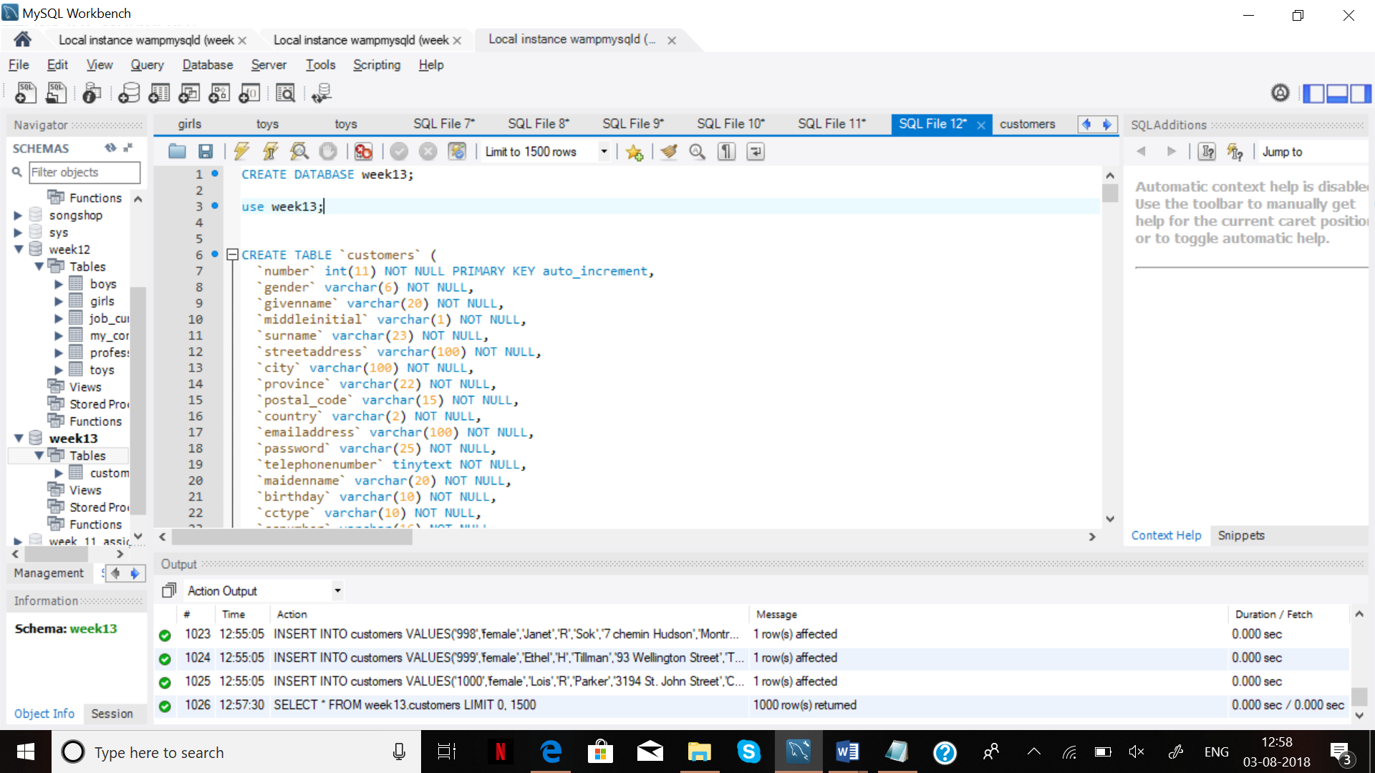

2. Download the ‘fakenames’ file from ‘Sample tables’ folder in ‘Weekly learning’ and create ‘customers’ table.

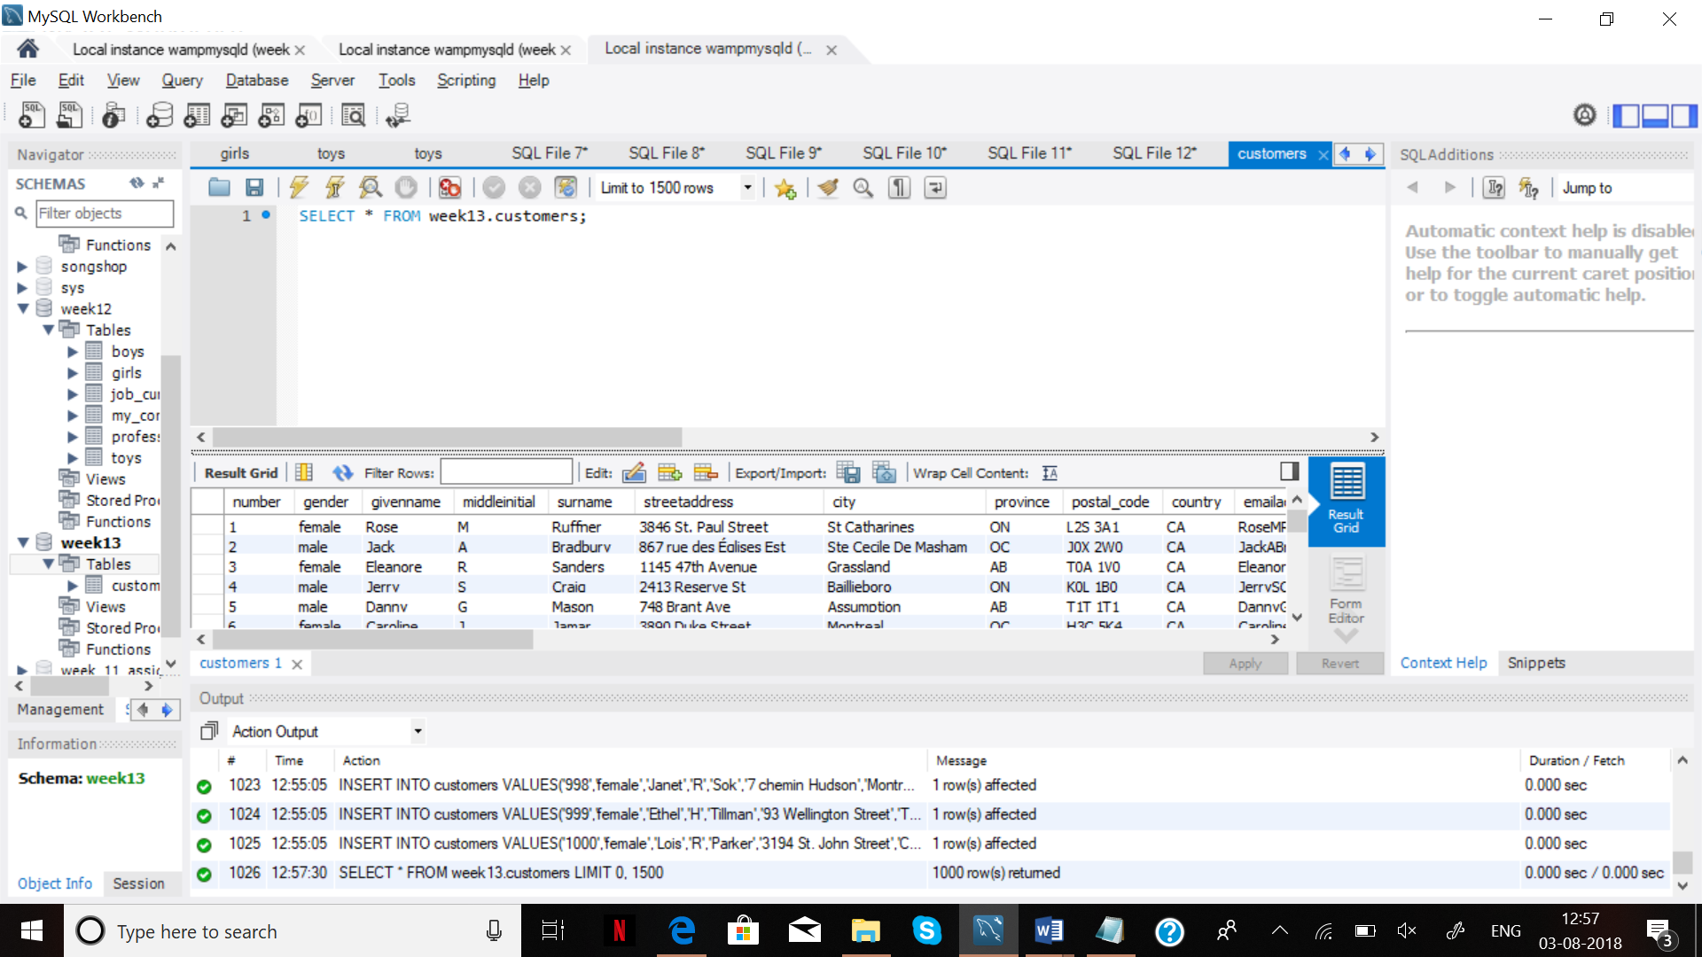

**STEP 2**

1- Change the column name (number) to (CUSID).

2- Create ‘Bonus’ table.

ALTER TABLE `week13`.`customers`

CHANGE COLUMN `number` `CUSID` INT(11) NOT NULL AUTO_INCREMENT;

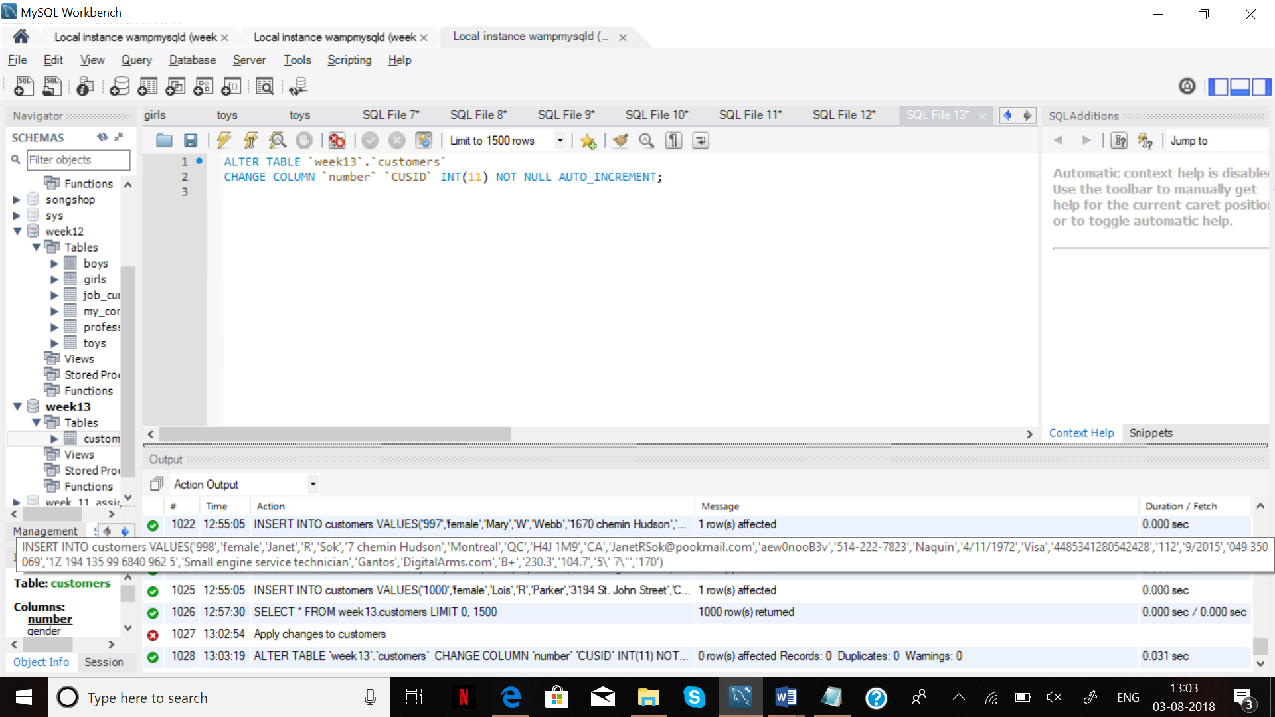

CREATE TABLE `week13`.`bonus` (

`ID` INT NOT NULL AUTO_INCREMENT,

`City` VARCHAR(30) NULL DEFAULT NULL,

`Bonus` DECIMAL(10,2) NULL DEFAULT NULL,

`CustomerID` INT(11) NULL DEFAULT NULL,

PRIMARY KEY (`ID`),

FOREIGN KEY (CustomerID) REFERENCES customers(CustomerID));

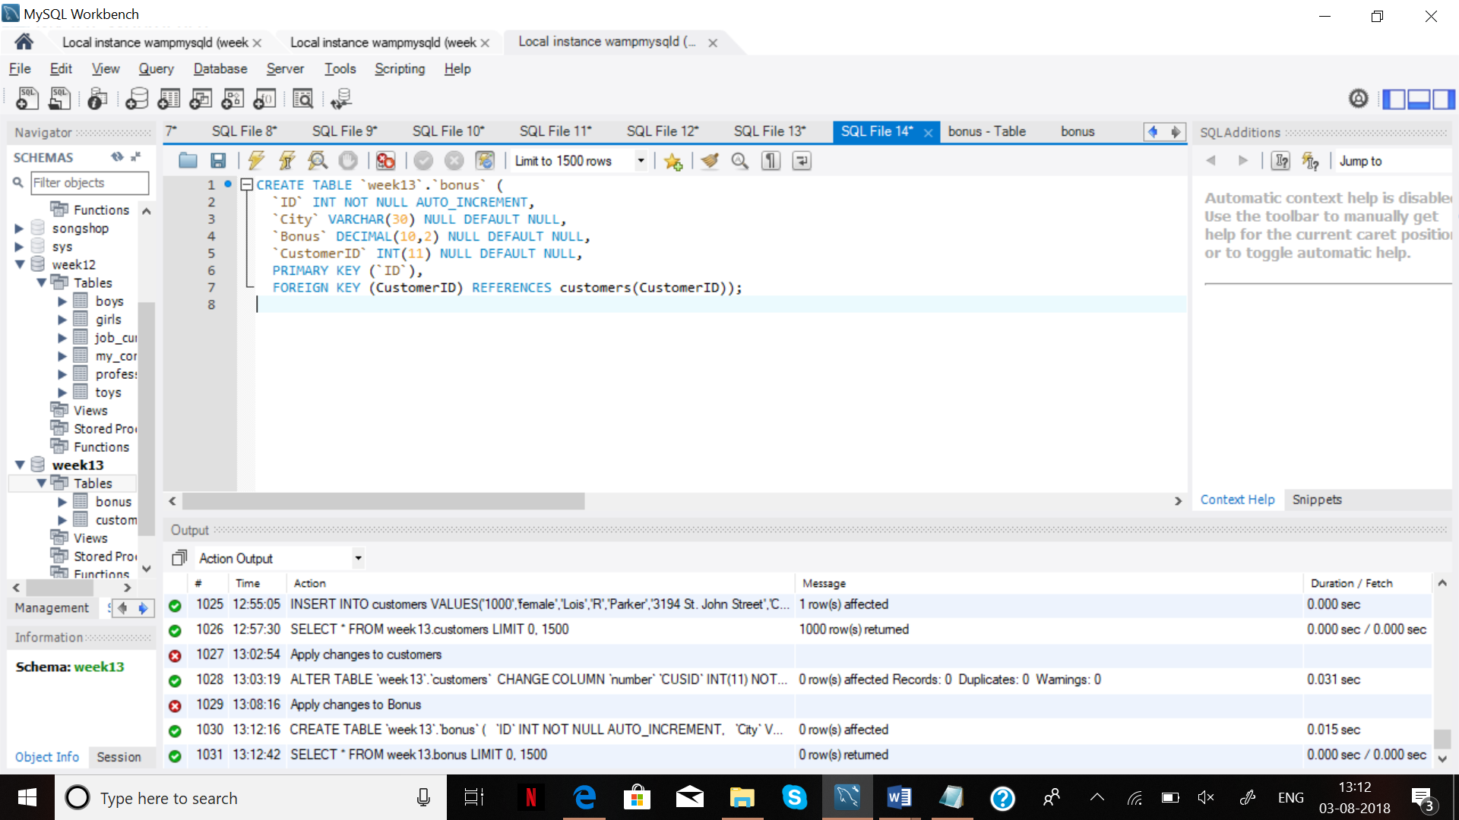

**STEP 3 -**

1- Update two columns (bonus and city). Get cities from ‘customers’ table and set bonus =100 for all cities.

INSERT INTO bonus (city) SELECT city FROM week13.customers;

UPDATE bonus SET bonus = 100;

SELECT * FROM bonus;

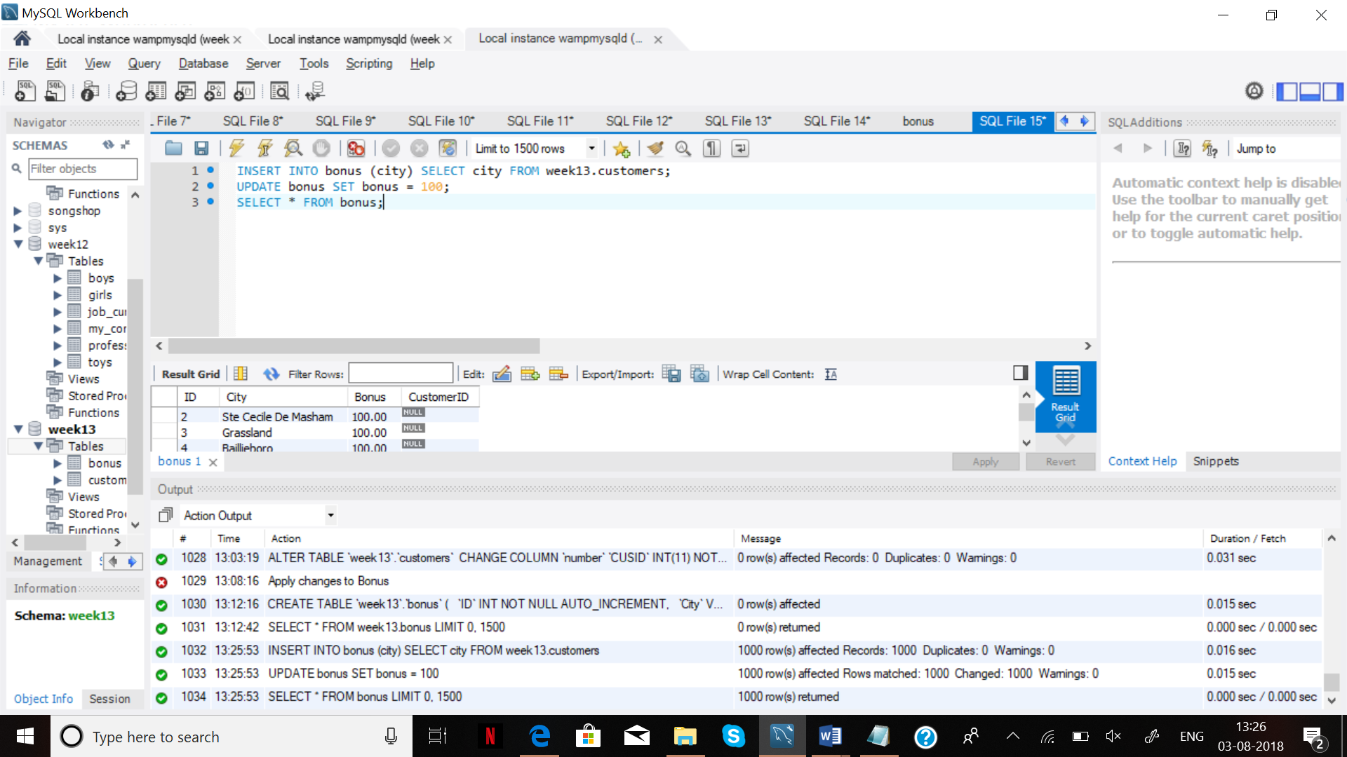

2- Add 100 CAD to the all customers living in Toronto, Red Deer, and Hamilton.

UPDATE bonus SET bonus = bonus + 100 WHERE city IN ('Toronto','Red Deer','Hamilton');

SELECT * FROM bonus;

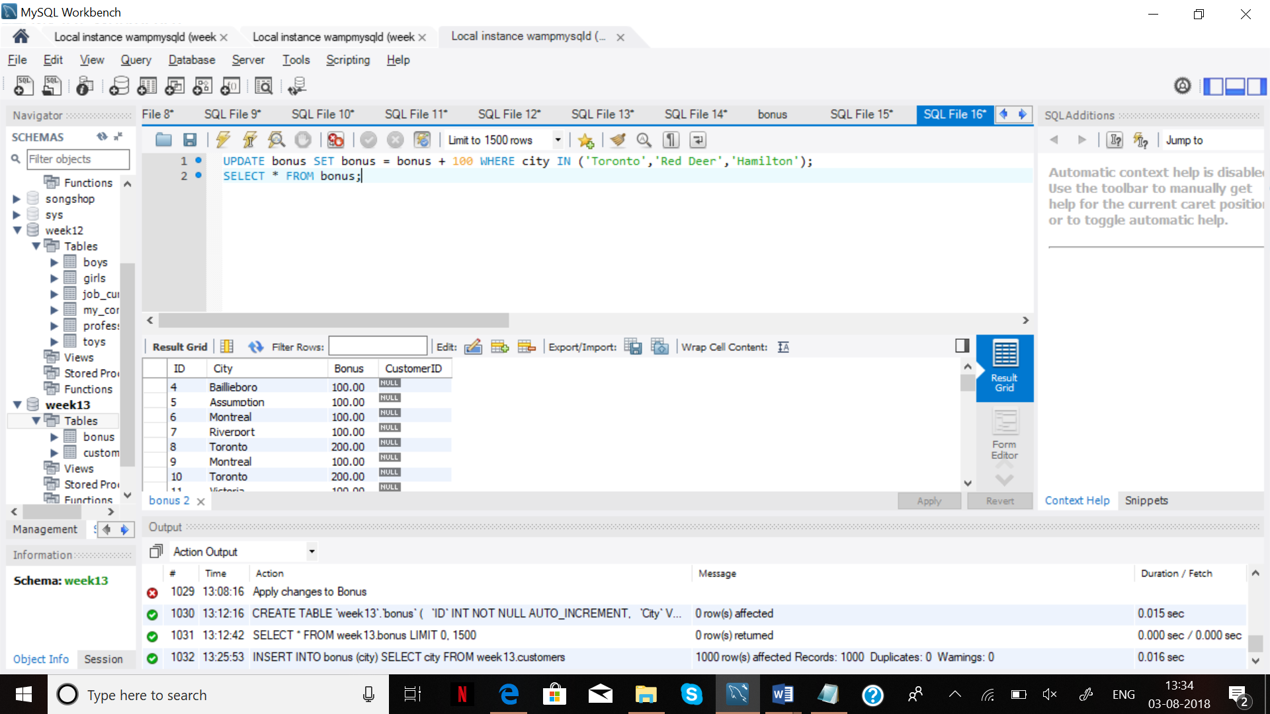

3- Add 23 percent to the bonuses of all customers who are living in the cities which have the ‘s’ letter in their city names.

UPDATE bonus SET bonus = bonus+bonus*23/100 WHERE city LIKE '%s%';

SELECT * FROM bonus;

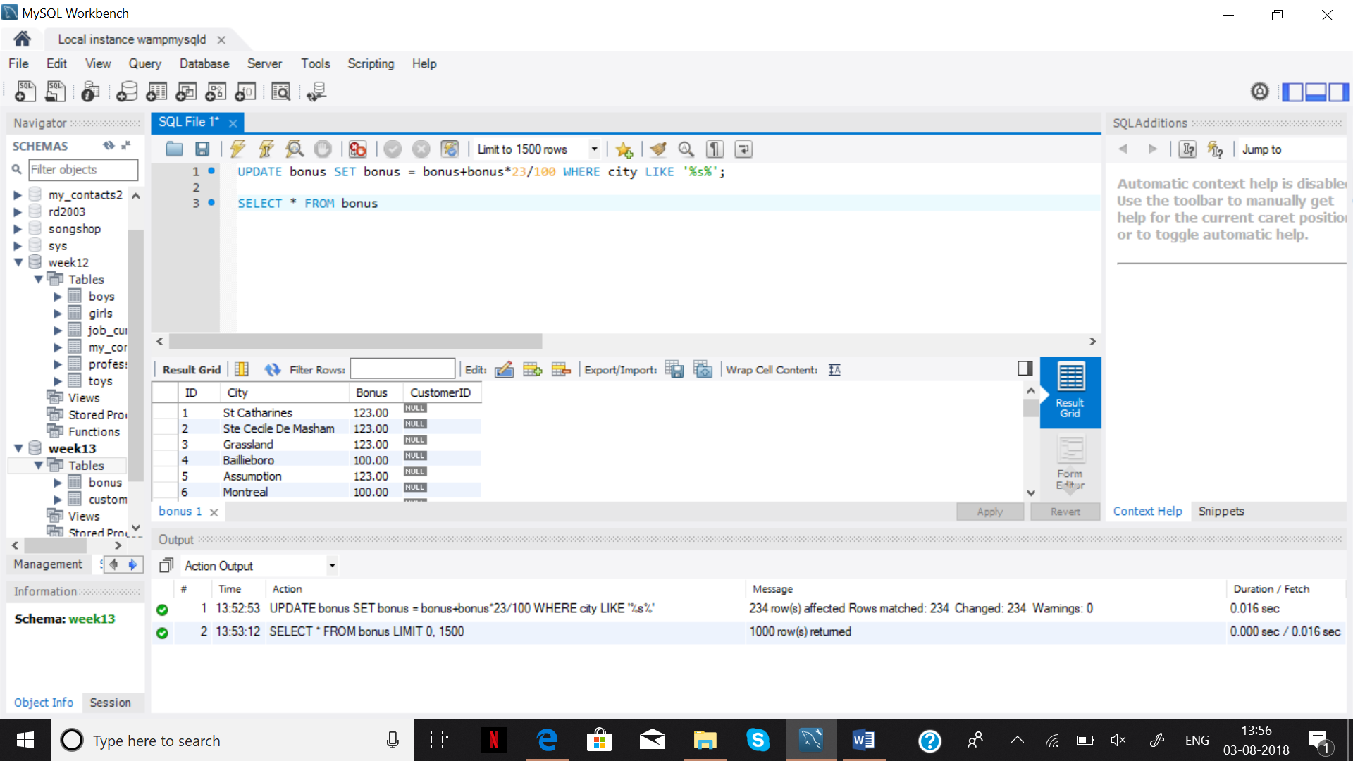

**Step 4.**

1- How many customers are living in ‘Barrie’? (Use ‘number of customers in Barrie' for the result’s title).

SELECT city, COUNT(city)

FROM customers

GROUP BY city = 'Barrie';

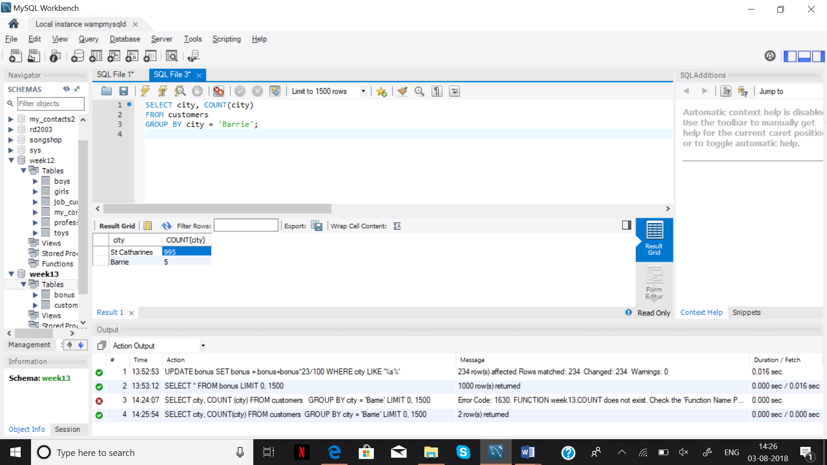

2- Add 33% bonus to these customers.

UPDATE bonus SET bonus = bonus+bonus*33/100 WHERE city = 'Barrie';

SELECT * FROM bonus WHERE city = 'Barrie';

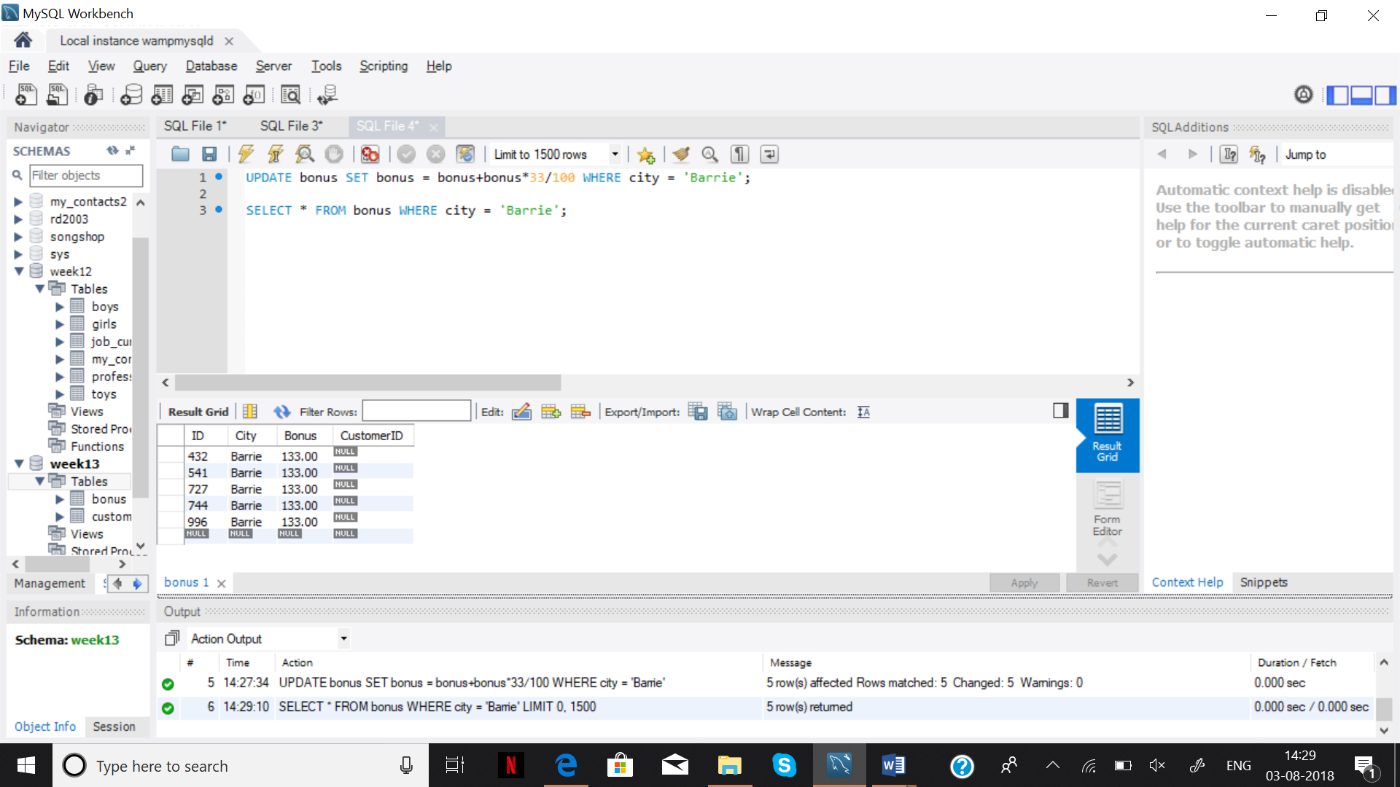

3- We want to see the names and bonuses and the customers who live in ‘Barrie’. (You can use join or subquery)

SELECT DISTINCT c.givenname,b.Bonus FROM customers c INNER JOIN bonus b ON b.city = 'Barrie' AND

c.city = 'Barrie';

**Step 5**

1- We need to increase the bonus amounts of the customers who get the minimum bonus amount. Find the minimum amount by a query and add 50.5 to all of these customers.

UPDATE bonus SET bonus = bonus + 50.5 WHERE bonus = (SELECT min(bonus));

SELECT min(bonus) from bonus;

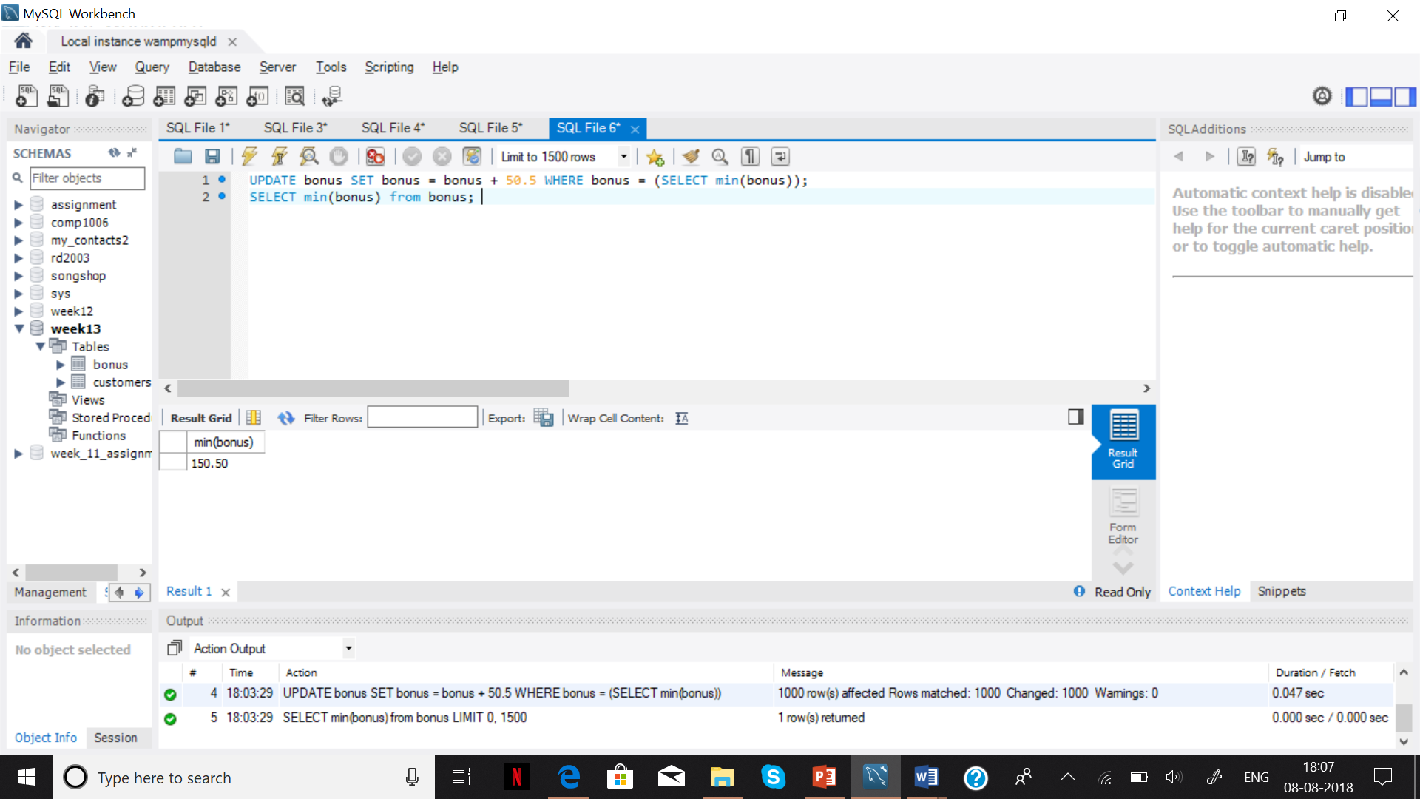

**Step 6**

1- Delete bonus of all cities starting with ‘F’;

DELETE Bouns FROM bouns WHERE city LIKE 'F%';

SELECT * FROM bouns WHERE city LIKE 'F%';

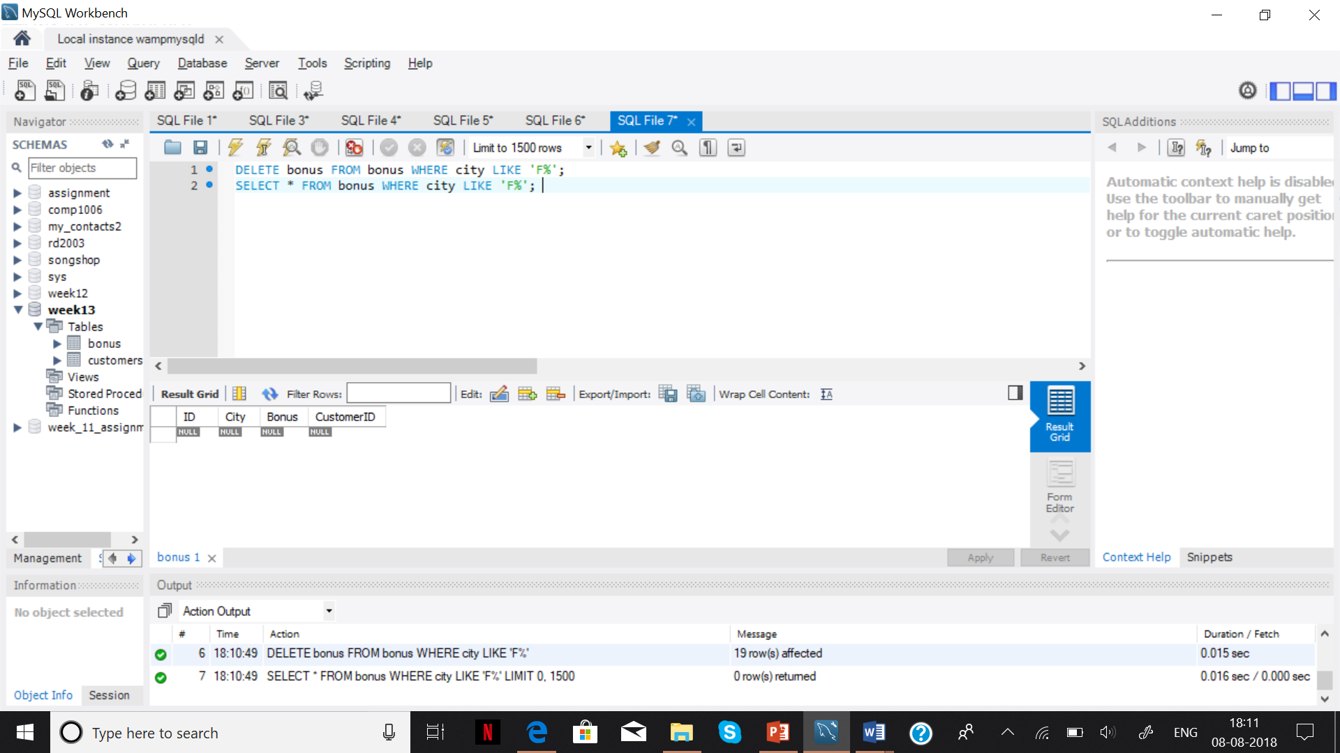

2- Calculate the average bonus of the cities not starting with E.

SELECT avg(bonus) FROM bonus WHERE city NOT LIKE 'E%';

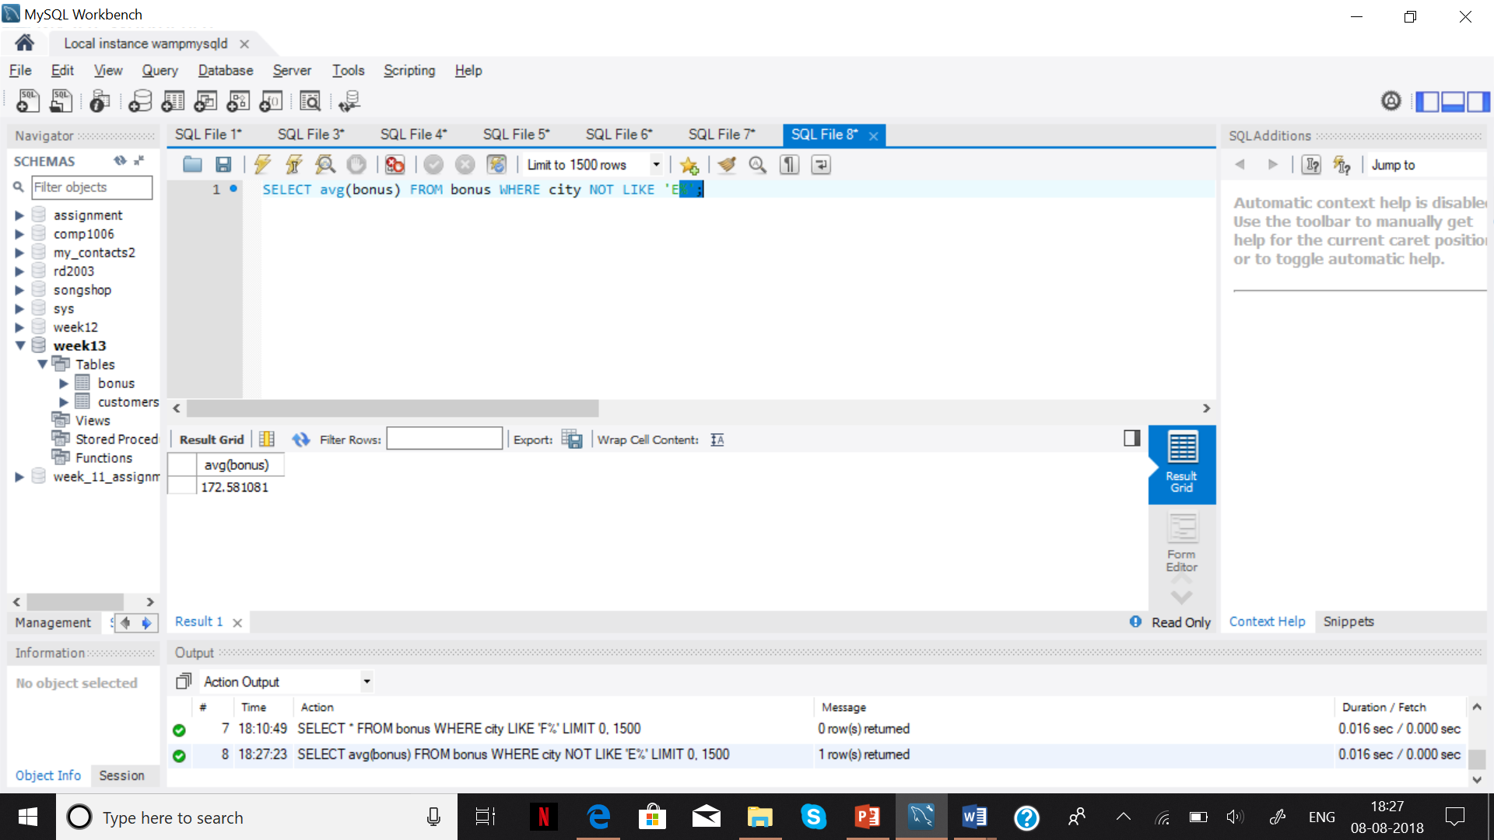

**Step 7**

1- Query all given name and street address of the customers who do not get any bonus. (Write the query with join not sub-query)

SELECT DISTINCT c.givenname, c.streetaddress FROM customers c JOIN bonus b ON c.city = b.city WHERE bonus = NULL;

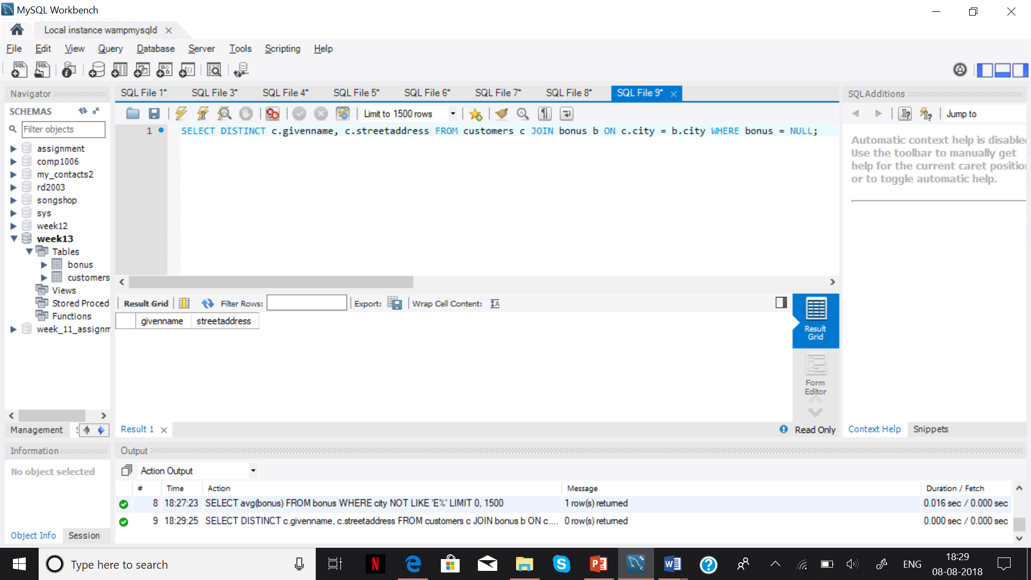

**Step 8&9:**

1- Add a ‘StreetNumber’ column in customer table after the surname;

ALTER TABLE customers ADD COLUMN StreetNumber INT(5) AFTER surname;

DESC customers;

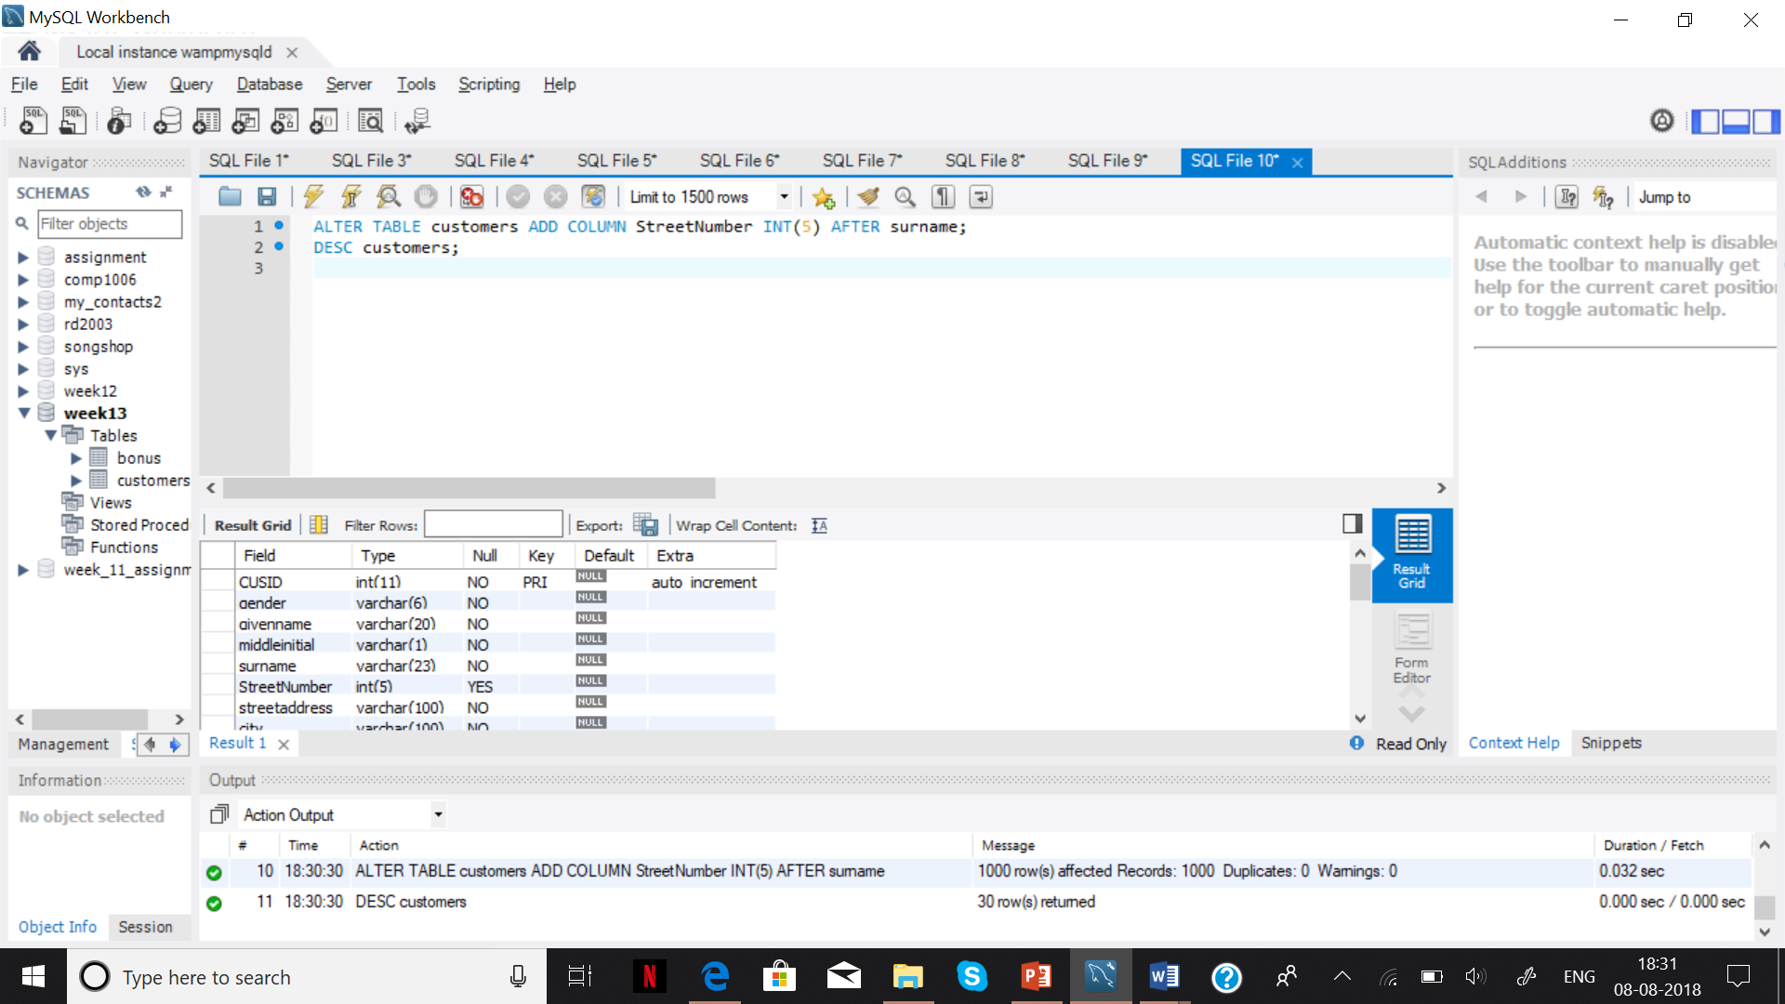

2- Copy Street number from Street address and add it to street number.

UPDATE customers SET StreetNumber = (SELECT SUBSTRING_INDEX(streetaddress, ' ', 1));

SELECT Streetnumber FROM customers;

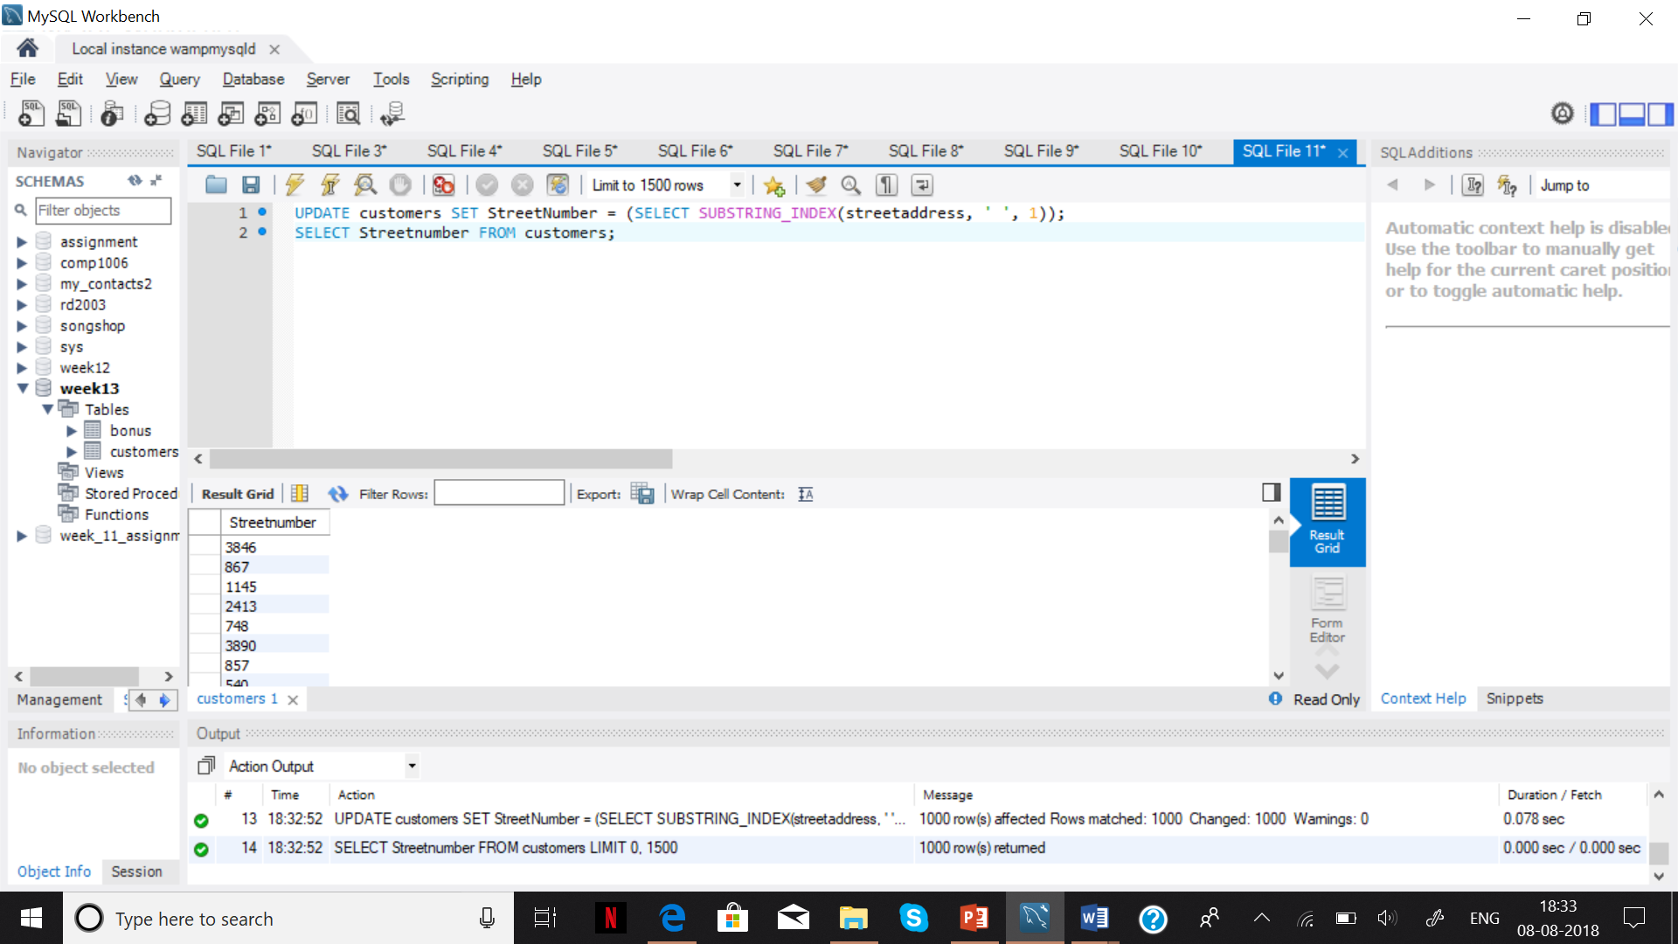

3- Cut the number before streetaddress.

UPDATE customers SET streetaddress =SUBSTRING(streetaddress, LOCATE(' ', streetaddress)+1)

WHERE streetaddress REGEXP '^[0-9]';

SELECT streetaddress FROM customers;

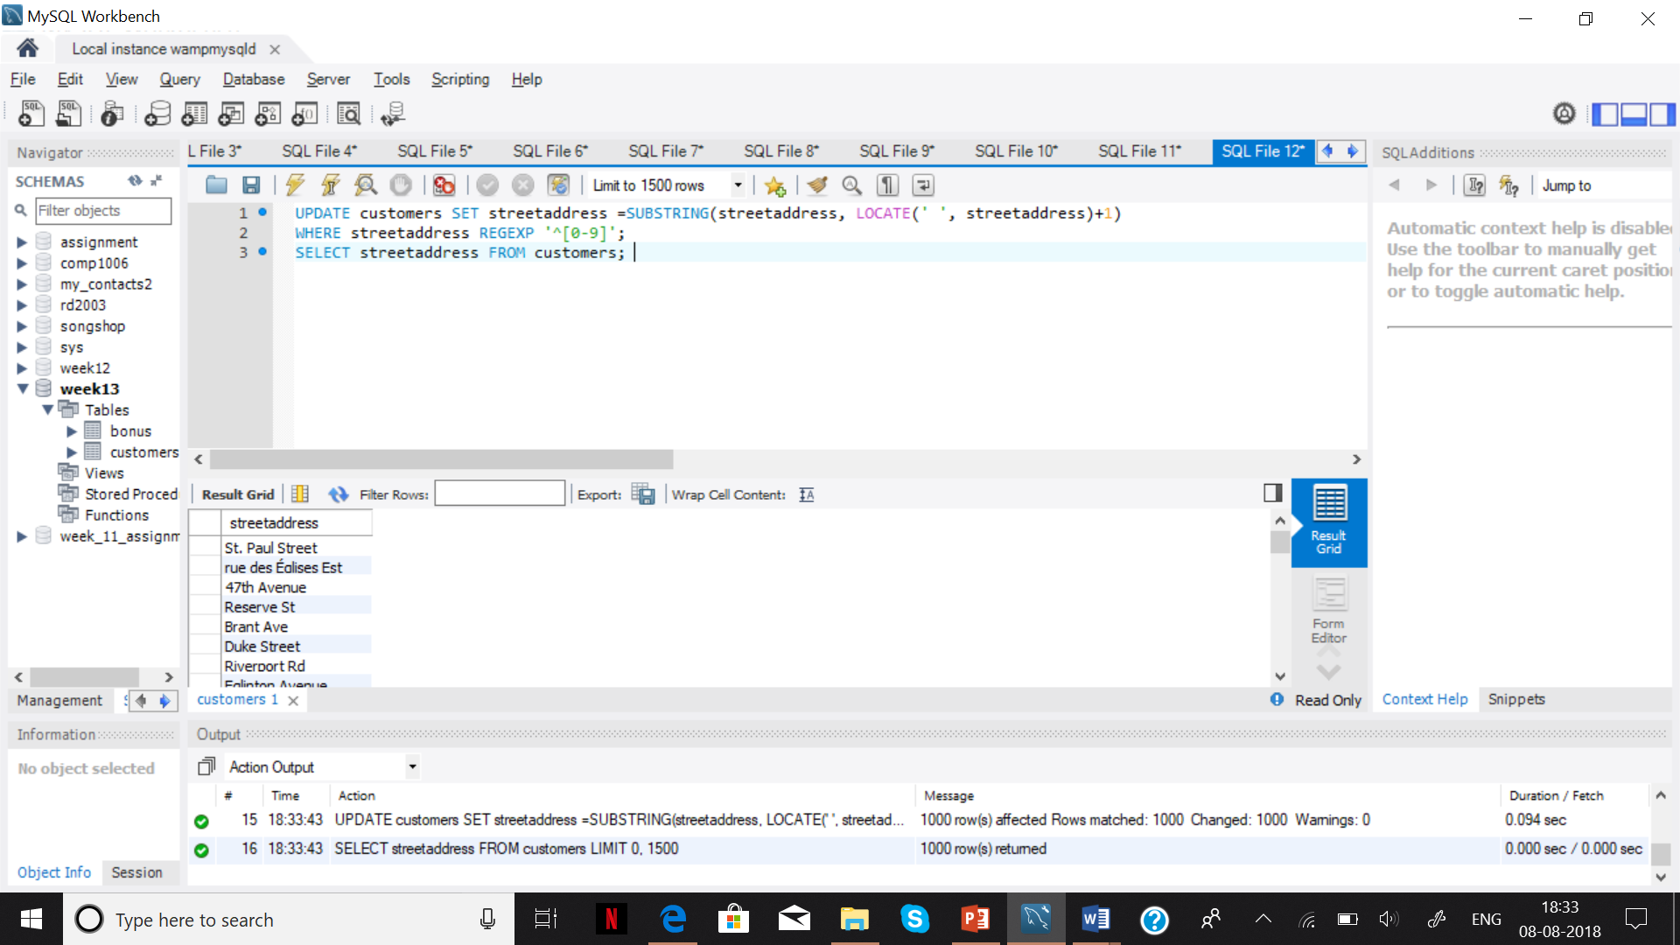

Step 10:

1- Show 2th top bonuses.

SELECT bonus FROM bonus ORDER BY Bonus desc LIMIT 2;

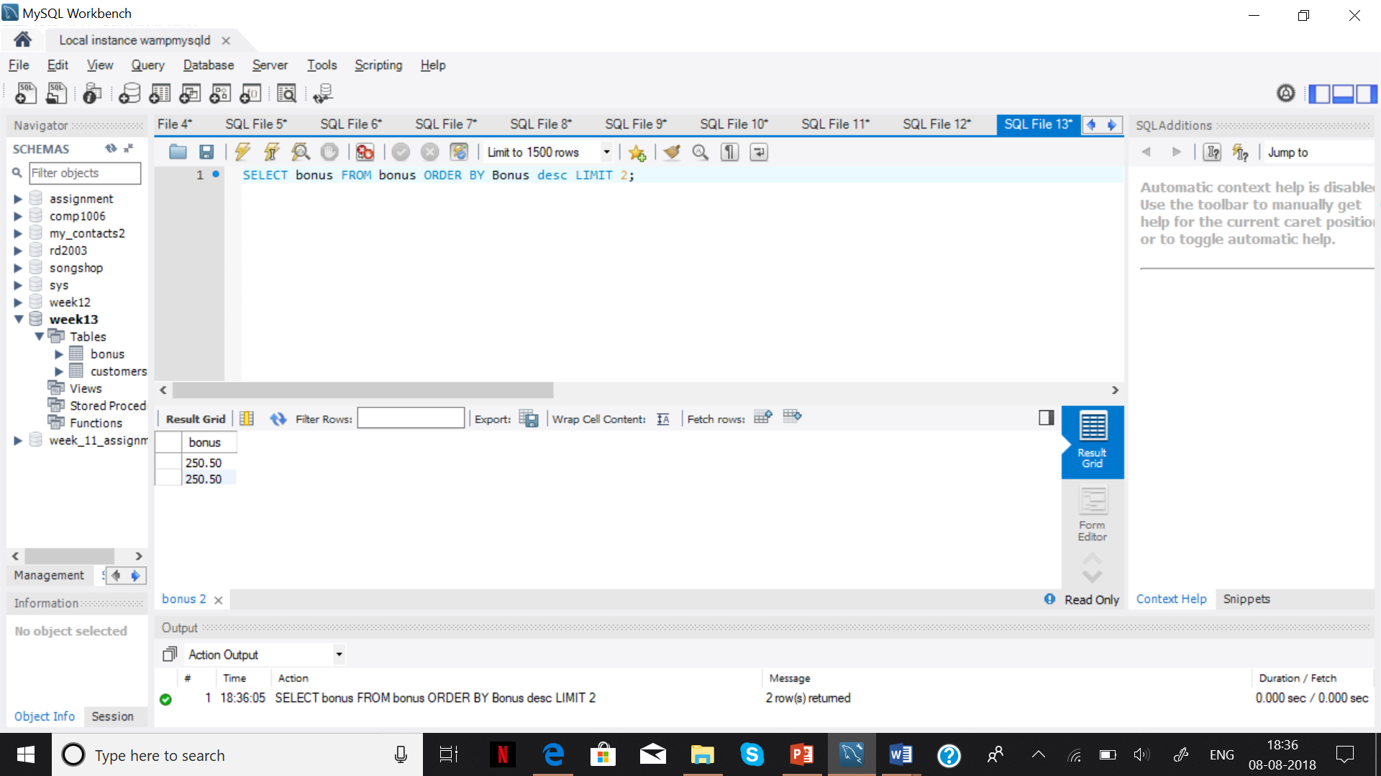

2- Show the total amount and average bonus in each city.

SELECT sum(Bonus) ,avg(bonus),city,count(city) FROM bonus GROUP BY city;

